Hatirjheel Scenario

Section: M

**Prepared by:**

MT. ZUBIDA KHATUN, 19-41677-3

SUMAIA MAHMUDA, 19-41622-3

Tofa Hossain, 20-41956-1

RAFID REDWAN KHAN, 20-42239-1

**Submitted to:**

MAHFUJUR RAHMAN

**1.INTRODUCTION**

Hatirjheel is a lakeside in Bangladesh's capital, Dhaka. It was a slum area before 2009, but it has now been renovated into a recreational area as well as a traffic-relieving alternative. The Bangladesh Army and the Special Works Organization built the region. According to legend, the elephants of Dhaka's Pilkhana bathed in these wetlands, thus the name Hatirjheel. The Bhawal Raja used to keep his domesticated elephants at Pilkhana, according to architect Iqbal Habib, who heads the consultant firm for the Hatirjheel-Begunbari construction project. The elephants were transported to the wetlands via the Elephant Road and Hatirpool, according to him.

**2. OBJECTIVE OF THE PROJECT**

The main purpose of the project is to display various environments of Hatirjheel.

The objectives are:

* Day view
* Night view
* Winter view

Here we tried to show some observations from Hatirjheel area. Like the lake with wastage and the purifying system, train, the tree leaves falling in the winter.

**3. METHODOLOGY**

The tool employed for generating the project is code blocks. The group members divided the work and did individual parts of the project and also worked on some things together. The information and ideas were collected from both real-life observation and virtual data.

The codes are written in particular functions and mainly the display function shows the day view, display1 function shows the night view and the winter function shows the winter view. The codes needed are called in these main functions.

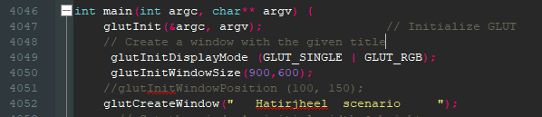

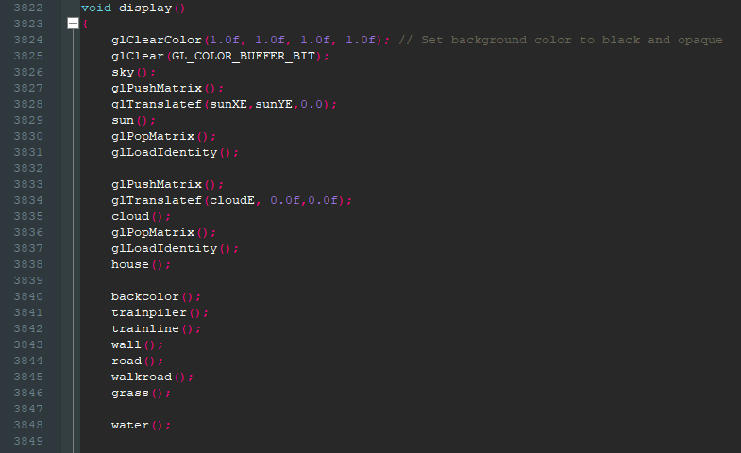

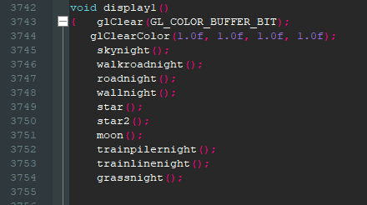

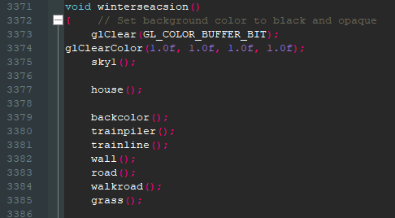

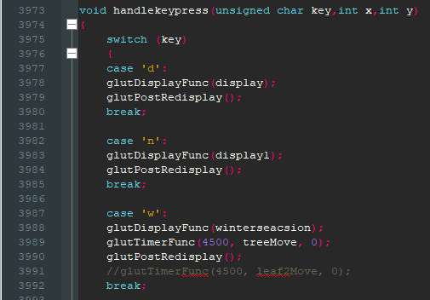

**4.CONCLUSION**

In this work, an attempt was made to portray one of the famous places of Dhaka City, which is Hatirjheel. The view of Hatirjheel during day, night and winter. A little glimpse of the city with buildings, train.

**5.REFERENCES**

1. <https://www.google.com/search?q=hatirjheel&source=lnms&tbm=isch&sa=X&sqi=2&ved=2ahUKEwicqtfEntv0AhWyGbkGHfvcA9gQ_AUoAnoECAIQBA&biw=1920&bih=969&dpr=1#imgrc=FsQYFVniqZ7_rM>
2. <https://www.google.com/search?q=hatirjheel&source=lnms&tbm=isch&sa=X&sqi=2&ved=2ahUKEwicqtfEntv0AhWyGbkGHfvcA9gQ_AUoAnoECAIQBA&biw=1920&bih=969&dpr=1#imgrc=ZPDsUkmfo6NjnM>
3. <https://www.free-stock-music.com/sunny-day.html>

**6.Screenshot of the System**

**Day view**

